**Sukuna Multiple Campus**

Name: DayaShankar Das

Symbol no: 76214008

Subject: OOP with C++

Submitted To: Uma Dungel

//Destructor

#include <iostream>

#include <conio.h>

using namespace std;

class Information{

public:

Information(){

cout<<"Constructor is called ";

}

~Information(){

cout<<endl<<"Destrutor is called ";

}

};

int main(){

Information info;

return 0;

}

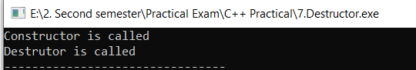

//Unary Operator overloading

#include <iostream>

#include <conio.h>

using namespace std;

class Counter{

int count;

public:

Counter(){

count=0;

}

void operator++(){

++count;

}

void getData(){

cout<<"Number is: "<<count<<endl;

}

};

int main(){

Counter count;

count.getData();

++count;

++count;

count.getData();

}

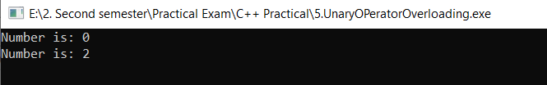

//Encapsulation

#include <iostream>

#include <conio.h>

using namespace std;

class Encaps

{

private:

int a,b;

public:

void set_data()

{

cout<<"Enter two numbers ";

cin>>a>>b;

}

void getdata()

{

cout<<"Addition of two number is "<<a+b;

}

};

int main()

{

Encaps E1;

E1.set_data();

E1.getdata();

return 0;

}

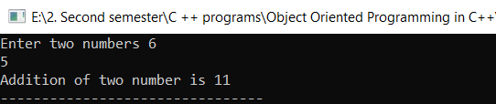

// Default Constructor

#include <iostream>

#include <conio.h>

using namespace std;

class DefaultConstructor{

public:

DefaultConstructor(){

cout<<"This is an example of default constructor\n";

}

};

int main()

{

DefaultConstructor d1;

return 0;

}

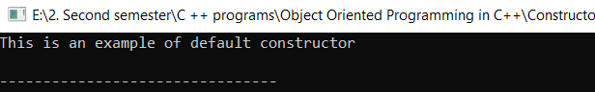

//template class

#include <iostream>

#include <conio.h>

using namespace std;

template <class temp>

class Calculator

{

temp n1,n2;

public:

Calculator(temp n1,temp n2)

{

this->n1=n1;//this->n1 is above private access specifier member

this->n2=n2;

}

void display()

{

cout<<"NUmber are "<<n1<<" "<<n2;

cout<<endl<<"Addition "<<add()<<endl;

}

temp add()

{

return n1+n2;

}

};

int main()

{

Calculator <int> cal(5,10);

Calculator <float> f(5.5,10);

cal.display();

f.display();

return 0;

}

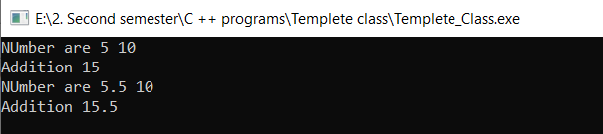

//Single level inheritance

#include <iostream>

#include <conio.h>

using namespace std;

class Base_class{

protected:

int age;

};

class Child_class: public Base_class{

public:

void myage()

{

age=18;

cout<<"your age is "<<age;

}

};

int main(){

Child_class ch;

ch.myage();

return 0;

}

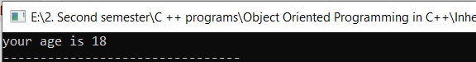

//Multiplication of two numbers

#include <iostream>

#include <conio.h>

using namespace std;

class Multiplication{

int a,b,mul;

public:

void setData(){

cout<<"Enter two numbers ";

cin>>a>>b;

}

void getData(){

mul=a*b;

cout<<"Multiplication of "<<a<<" and "<<b<<" is "<<mul;

}

};

int main(){

Multiplication multiplication;

multiplication.setData();

multiplication.getData();

}

